**Estée Lauder**

**雅诗·兰黛**

(英文部分选自经济学人20040429讣告)

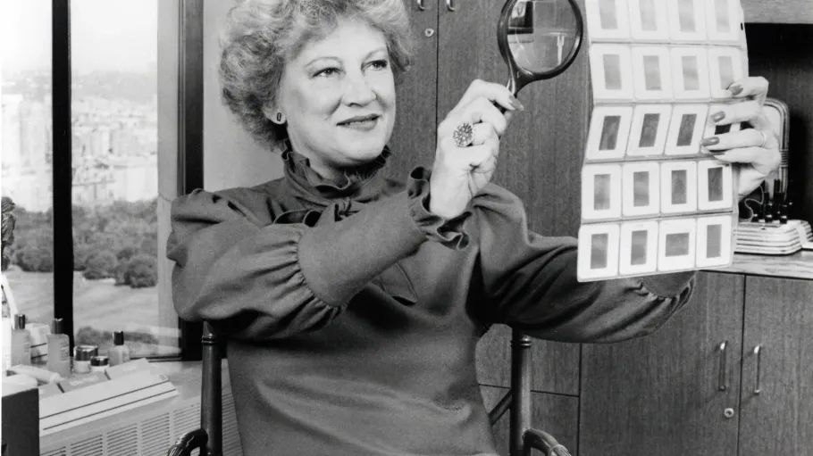

‍Estée Lauder

雅诗·兰黛

Estée Lauder, queen of cosmetics, died on April 24th, at a mature age

化妆品女王雅诗·兰黛，于2004年4月24日过世，年至耄耋。

**A number of newspapers thought Estée Lauder was 97 when she died**. Others averred that she was 95. **Most agreed that, until a broken hip slowed her down in 1994, she did not look her age, whatever that was**. If anything, the hair had grown blonder and the skin tighter. Outrageous purple outfits, topped by natty hats, reproduced something of the glow of youth.

**多家报纸报道雅诗·兰黛去世的年纪是97岁**，还有其他报纸断言称她实际是于95岁逝世。**不过大多都同意，在她身上看不出真实年龄，直到1994年髋骨骨折导致她行动迟缓才显出老态**。要说有变化，那就是年纪越大头发越金，皮肤越紧致。鲜艳夺目的紫色套装，精巧时尚的帽子，都传递着青春焕发的活力。

**Subservience to hard facts, such as time and decay, seldom held Mrs Lauder back**. **Her own background was a study inselective self-improvement**. By changing her name, acquiring that dainty little lift of an accent aigu, she suggested to customers that her background might be aristocratic and even European. French and Italian blood was hinted at, as well as a convent education. **Her father, a monarchist by her telling**, felt undressed in the street on Sundays without a cane and gloves.

**常人都向岁月和衰老这些铁一般的事实低头，但她却很少为之所困**。**她的人生历程就是一部有的放矢的自我奋斗史**。她改了名字，名字里带有小巧而精致、音调上扬的法语闭音符，让顾客以为她具备贵族甚至欧洲背景。新名字同时还暗示她可能拥有法国和意大利血统，接受过修女教育。**据她所言**，她父亲拥护君主制，认为周日上街不拿手杖不戴手套就等于没穿衣服。注释：关于改名：Estée Lauder原名是Josephine Esther Mentzer，为正常美国（纽约）人名，文中提到的是Estée的闭音符号（accent aigu）。Lauder为随夫姓。

These details **were sprung on** the world in 1985, **in a book that accompanied the launch of a new perfume, “Beautiful”**. For the promotion in Paris, Mrs Lauder had bought up all the pinks in the city to match both the perfume boxes and the book's cover. This sensory extravaganza was designed to eclipse an unauthorised “inside story” of her life. Under covers of cream and blue (so tastelessly passé!) her rival revealed that Mrs Lauder's parents, Hungarian Jews, had run a seed and hardware store in Queens, a run-down borough of New York. The young Estée had probably not finished her studies at Newtown High School. Her first jars of face cream had **been cooked up** not just in a kitchen over a gas stove, but also in a makeshift lab in a stable, and by an uncle whose chemical experiments stretched not only to “Viennese Cream” but to lice-killer and embalming fluid.

**以上这些细节都是在1985年她出版的新书中公布的，出版时间恰逢新款香水**：**美丽（Beautiful）上市**。为了巴黎的推广活动，她买下城里所有的石竹花来搭配香水包装盒和新书的封面。这场感官盛宴的风头盖过了另外一本非官方讲述她生活“内幕”的书。那本书封面的色调是奶油色和蓝色（过时的设计！），她的竞争对手在书中揭露，她的父母是匈牙利犹太人，曾经在纽约破败的皇后区经营一家种子和五金店。她甚至可能都未能完成在新城高中的学业。她的第一罐面霜是和她舅舅一起在厨房的煤气灶上熬制出来的，而且实验室是在马厩里临时搭建的。而她舅舅的化学试验不仅发明除了维也纳面霜，还有灭虱药和防腐剂。

These revelations, about a woman who now counted among her friends Princess Diana, Nancy Reagan, the Gorbachevs and the Begum Aga Khan, were somewhat irritating. **Yet it was scarcely a tale to be ashamed of.** Young Josephine Esther Mentzer, as she began, was convinced from childhood that women should be beautiful. She also hoped to make a fortune by persuading them that, if they bought her creams, their beauty would last for ever. It is a story, after all, that women tend to need to believe.

她如今交往的朋友都非富即贵，像戴安娜王妃、南希·里根、戈尔巴乔夫家族和阿迦汗家族等，这些爆料多少有点让她恼火。**然而，这些故事并不可耻**。她的原名叫作约瑟芬·埃斯特·门策（Josephine Esther Mentzer），从小就坚信女性应该美丽。她说服女性称，如果用了她的面霜，便能永葆美丽。她也希望以此发家致富。毕竟，所有女性都愿意相信青春永驻的故事。

**With tireless energy, she devoted her life to both causes**. She began in the 1930s in the beauty salons of Queens, finding an audience held captive under hairdryers and dabbing their hot cheeks with her uncle's inventions. In 1948, Saks Fifth Avenue took a consignment; it sold out in two days. Steadily, Mrs Lauder acquired shiny counters in more and more department stores. With the help of a friend she branched out in 1953 from creams into Youth-Dew, a bestselling bath oil and perfume combined, and became the doyenne of all beauty.

**她精力旺盛，全身心地投入到了这两项事业中**。上世纪30 年代，她的事业在皇后区的美容院起步。她瞄准了正在用吹风机吹干头发的顾客，在她们（被吹风机吹得）发烫的脸颊上轻轻涂上她叔叔研制的产品。1948年，萨克斯第五大道精品百货店开始销售她的产品；两天内便销售一空。慢慢地，她在越来越多的百货商店里设立起闪闪发光的专柜。1953 年，在一位朋友的帮助下，她扩大了产品范围，从面霜到香氛沐浴油——“青春之露”，非常热销，而她也成为了全域美容的元老级人物。

Tactility was her byword. She loved to plunge her fingers in her own gently simmering creations, palpating and inhaling them. Her creams came in heavy jars, her lipsticks in cool metal sheaths, to advertise their quality. Whenever she could she smoothed them on customers herself, achieving a “gentle glow” that was immediate and miraculous. For a time, Fifth Avenue was not safe from her. Sales staff at Estée Lauder counters were trained by her to get similarly intimate with customers. Free gifts, then an innovation, were handed out with every purchase, and free samples were sent to aristocrats in Europe. The distinctive Estée Lauder blue-green was devised to harmonise with most rich people's bathrooms. By 2000, more than half of all cosmetics sold in America were hers.

她重视“触感”。她喜欢把手指伸入自己精心焙制的产品里，感受质地、品悉气味。她把面霜装在有分量的罐子里，口红使用时尚的金属外壳，彰显产品品质。只要有机会，她就会亲自为顾客涂抹产品，瞬时实现“柔光”奇效。她曾红到都不能去第五大道。她亲自培训雅诗兰黛专柜的销售人员，以便她们能像她一样与客户建立亲密关系。她还开创了每一单都有赠品的先河。欧洲的贵族则会收到免费的试用品。雅诗兰黛特有的蓝绿色包装也是为了与大多数富人的浴室相协调。到2000年，在美国售出的化妆品中有一半以上是她的产品。

Whether women actually became more beautiful by applying Body Performance Anti-Cellulite Visible Contouring Serum, or whether they would have done as well with a quick douse in cold water, is impossible to say. Clearly, many felt better for it. The very names of these products, energetic and pseudo-scientific, implied that the limits of knowledge had been searched. Mrs Lauder could have cut prices, but refused. Her Crème de la Mer, developed by a NASA scientist, cost $110 for an ounce of vitamins pulped with seaweed. But cheapness, she said, would shake her customers' faith.“

纤盈动感塑形美体精华”是否真的能让女性变美，还是功效与洗冷水浴差不多很难定论。显然，许多人更青睐美体精华。这些产品的名字都活力满满，看似科学，这说明研发者早已对人类认知所存在的局限性做足了功课。她本可以把产品的价格定得低些，但她没这么干。雅诗兰黛的“海蓝之谜”产品由美国国家航空航天局（NASA）的一位科学家研制，主要成分包含各种维生素和海藻萃取物，售价高达每盎司110美元。尽管如此，她还是认为廉价会动摇顾客对产品的信任。

Over the decades she became very rich. By this year, her personal fortune stood at $233m and the worth of her company at $5.4 billion, with annual sales of $5 billion in 130 countries. Mrs Lauder was asked to be ambassador to Luxembourg, but declined when her husband said he did not want to carry her bags. Fabulous dinners were arranged, with gifts of Cartier silverware and with the candles set low on the tables to cast a flattering upward light on the assistance. The New York gossip columns trailed her obsessively, and still could not find out how old she was.

几十年来，她赚得盆满钵满。截至今年，她坐拥2.33亿美元的个人财富，公司价值54亿美元，产品在130个国家销售，年销售额高达50亿美元。她曾受邀出任驻卢森堡大使，但因丈夫拒绝帮她拎包而婉言谢绝了。她举办盛大的晚宴，用卡地亚银制器具作为宴会礼品；餐桌上的蜡烛特意摆得很低，自下而上投射出来的烛光，更好地营造了气氛。《纽约时报》的八卦专栏穷尽一切招数挖掘她的信息，却始终无法得知她的真实年龄。

Time, however, also trailed her, with his ghastly wrinkled face and his sallow hue that co-ordinated with no bathrooms. In 1988 she asked her elder son Leonard, then CEO of the company, to start dyeing his hair, as he was making her look old. That year the company brought in bleached wood and etched glass for its counters, a new blue for its packaging and more androgynous models who **glowed with** energy and health. Long before the death of the matriarch, Estée Lauder Companies Inc had been gently, but necessarily, moving out of her ageing shadow.

然而，岁月的痕迹还是如影随形：皱纹密布的脸，暗淡无光的头发，与装扮美丽的盥洗室格格不入。1988年，她要求时任公司首席执行官的大儿子莱昂纳德开始染发，因为儿子会让她显得很老。同年，公司为旗下专柜引进了漂白木材和蚀刻玻璃，产品更换了蓝色的新包装，并聘请了更中性的模特（他们都散发着活力和健康的光芒）。其实，早在这位女掌门去世之前，雅诗兰黛公司就已经逐渐摆脱了创始人不再年轻的阴影。